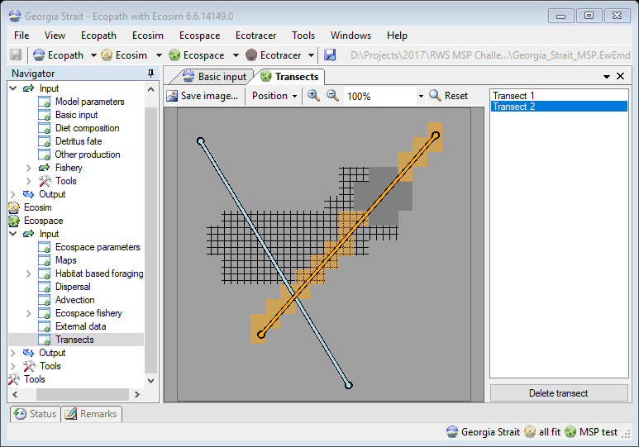
Figure 1 – Transects input screen, where transects are defined through simple sketching. The map shows transect lines superimposed on the depth and MPA map layers. The grid cells for the selected transect (orange line) are rendered in orange too.

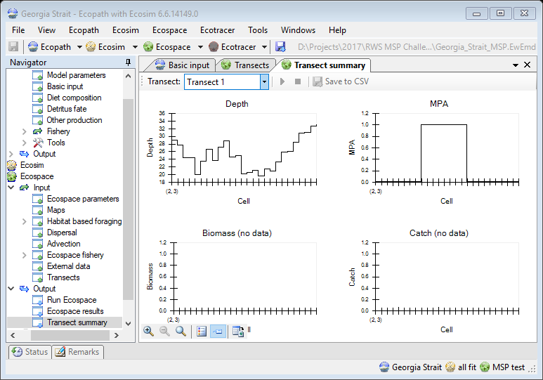
Figure 2 - The transect summary screen that displays data across the transect: depth profile, overlap with MPAs, and computed biomass and catch per group. In this particular screenshot Ecospace has not ran yet. The animation controls and save to CSV options are therefore disabled.

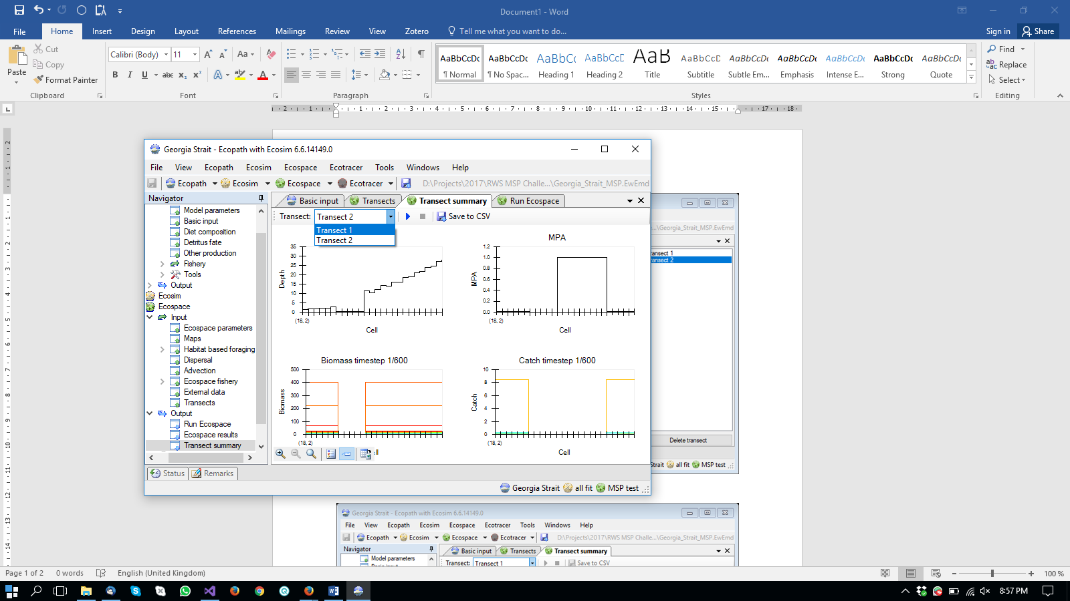
Figure 3 - Transect summary screen after running Ecospace. Note that transect 2 crosses the one and only MPA and a few land cells. Biomass and Catch are unavailable for land cells. Catch is 0 within the MPA. Also note that the animation controls and the Save to CSV options are available once Ecospace has executed.
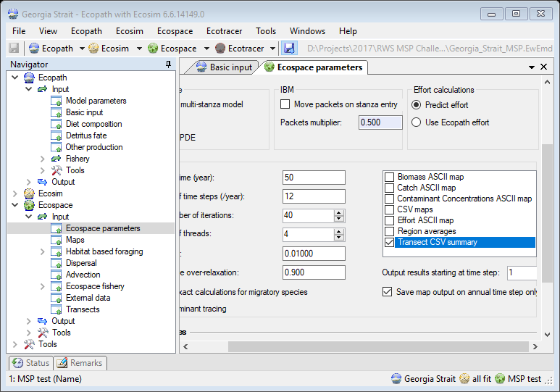
Figure 4 - Transect summary CSV files can also be saved automatically when Ecospace runs on the Ecospace parameters page.

